Assignment -3

|  |  |
| --- | --- |
| Date | 18 November 2022 |
| Student Name | V.Nishanthini |
| Team ID | PNT2022TMID32892 |
| Project Name | News Recommender application |

**1.Create a Bucket in IBM object storage.**

Bucket created in object storage

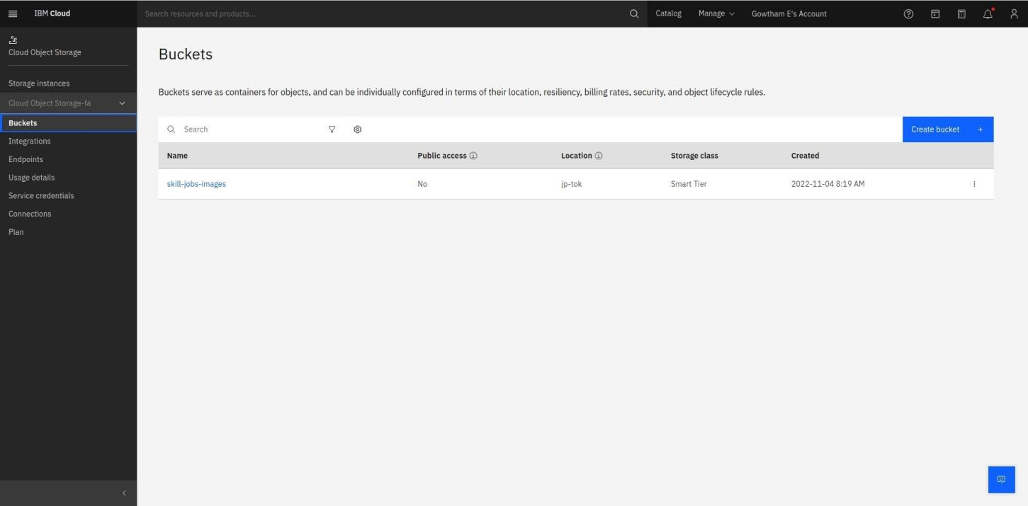

1. **Upload an 5 images to ibm object storage and make it public. write html code to displaying all the 5 images.**

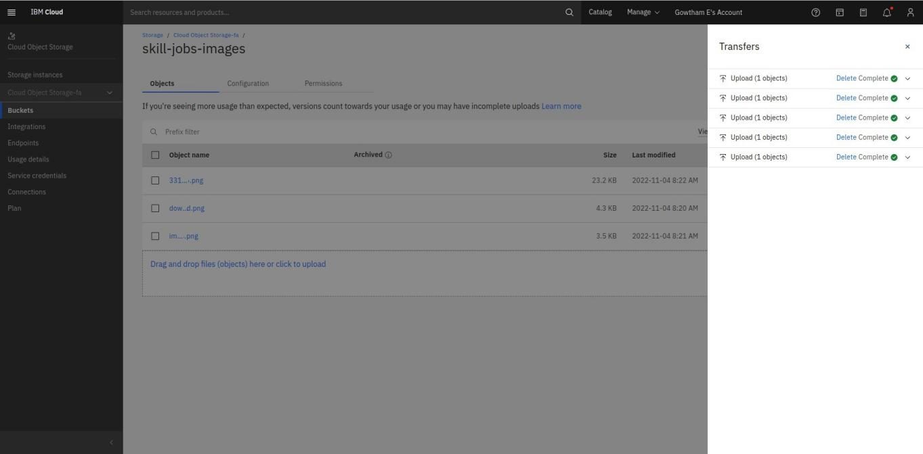Images added to the Bucket

1. **Upload a css page to the object storage and use the same page in your HTML code.**

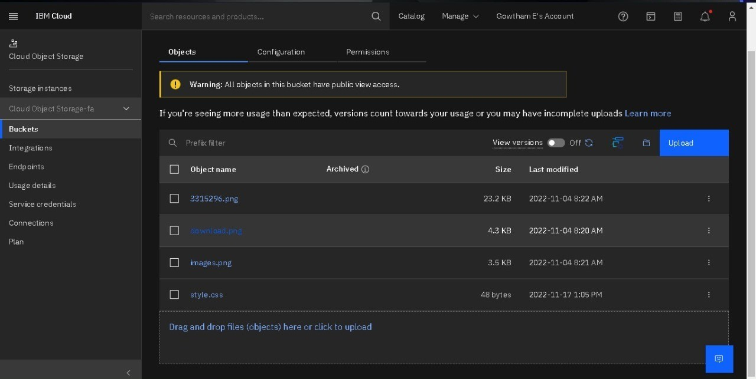

1. **Design a chatbot using IBM Watson assistant for hospital. Ex: User comes with query to know the branches for that hospital in your city. Submit the web URL of that chat bot as a assignment.**

URL:

https://web-chat.global.assistant.watson.appdomain.cloud/preview.html?backgroundImageURL=https%3A%2F%2Fus-south.assistant.watson.cloud.ibm.com%2Fpublic%2Fimages%2Fupx-51ccf44d-52c8-42ba-b034-6745a47e2f8a%3A%3Aa5cd1dcf-76a2-41b5-803a-ce72ce6a1ae6&integrationID=a1fecb98-2c1d-4d1d-b93b-26391d6efda1&region=us-south&serviceInstanceID=51ccf44d-52c8-42ba-b034-6745a47e2f8a

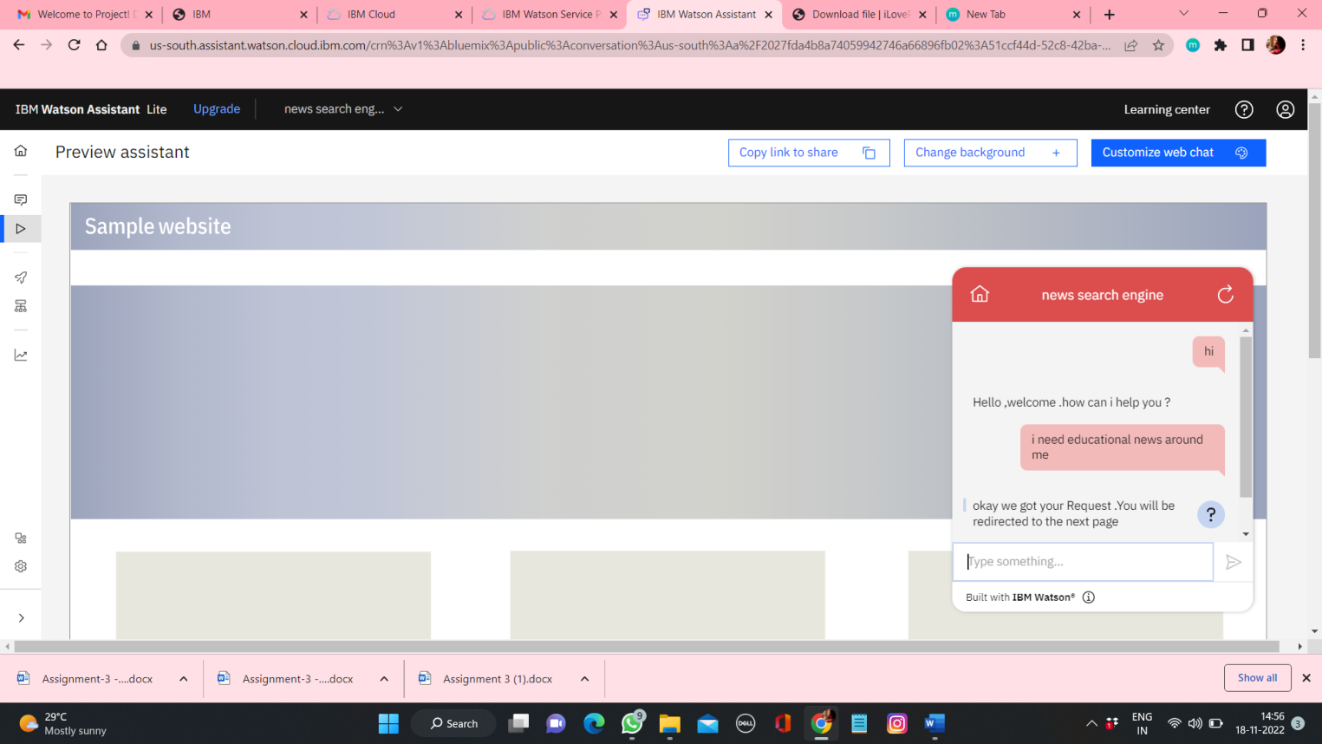

**5.Create Watson assistant service with 10 steps and use 3 conditions in it. Load that in a html page.**

